- The rising Chinese-style fast food competing with western leading peers
It was the spring in 1984 that KFC, like a thunderstorm, opened Chinese fast food era.

After years of development, China’s fast food market is expanding rapidly at an average annual growth rate of 18%. The fast food segment accounted for 20.8% of total catering industry revenue in 2016 according to China’s Ministry of Commerce. Mintel’s report forecasts an RMB 1 trillion sales revenue in fast food industry in 2021.

The proportion of fast food in catering industry is 35% in U.S, 30% in Europe and 20% in Japan. However, in China, even in the first-tier cities like Beijing and Shanghai, the figure only stands at 5%. In addition, China's per capita consumption of fast food is only 1/4 of developed countries.

All numbers indicate a positive future of China fast food industry. Thus, lots of capital including cross-border capitals are injected to the industry.

But how is the market structure of fast food industry? About 90% of the fast food restaurants are the Chinese-style while the rest 10% are the western-style, leading by the giants like McDonald’s and KFC. But the market share of these two dropped to 37.7% from the peak 57%. Chinese-style fast food is encroaching their cake.

The shift in the fast food industry catches our eyes. We want to figure out what kind of people they are losing by peeking the swift of consumer preference, which is well illustrated by a rating app “Dianping” with huge user base. Then try to give a portrait of one group of people that western-style fast food failed to grab.

- Ratings may tell
We choose McDonald’s, KFC, Kungfu restaurant, Wallace and Café De Coral for comparison, covering overseas and domestic enterprises as well as Western-style and Chinese-style food (including mainland and Hong Kong styles).

We scraped their Shenzhen rating data of tastes, environments, services, per capita consumption price, comment-volumes and levels of the customers, which may give us some consumer insights.

- Sometimes they just run neck and neck.
We used “pandas” module to analyse data we scraped and draw a radar chart, as seen from the radar chart, average scores remarked by customers of five fast food chains are quite similar - scores for food flavour are around 7.2, for restaurant environment are around 7.3, and for service are around 7.2; Also, 75% of restaurants in five brands are under around 7.4 average scores for food flavour, restaurant environment and service, showing that these five fast food chains are under homogeneous competition.

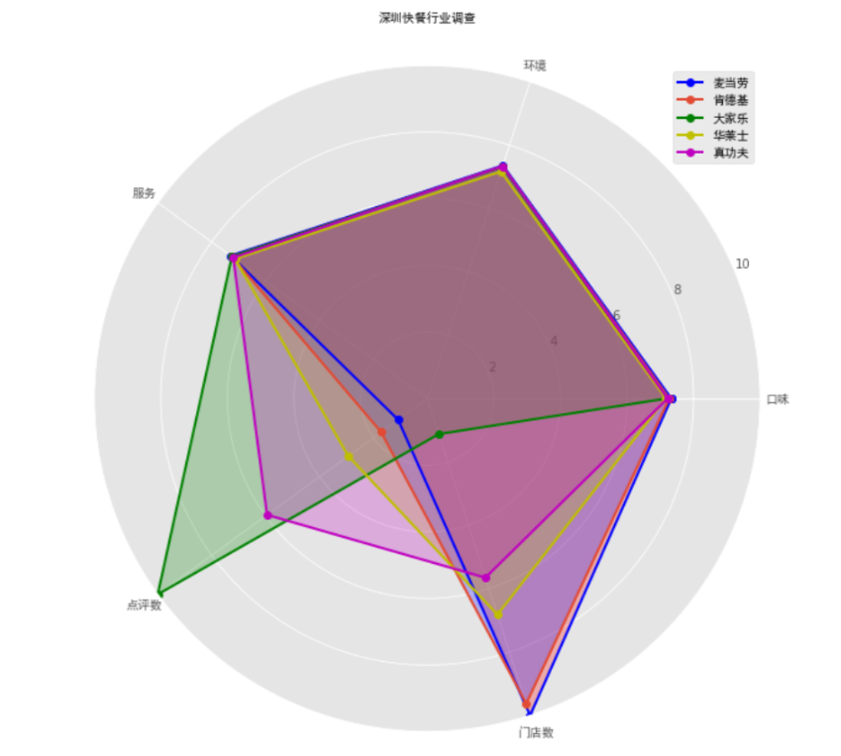
Homogeneous competition, according to MBA library, is the competition between different brands trying to imitate each other in the same industry. Competition based on the homogeneous product, which (from the consumer's viewpoint) have little or no differentiation in terms of features, benefits, or quality, therefore, forced to compete on price or availability.

According to Phoenix news, a researcher said that company competition can easily be homogeneous because of same features in products and company; Inadequate growth is one of the biggest challenges that western fast food chains are faced in recent years, making the homogeneous competition in fast food industry become more drastic.

In terms of food flavor, all popular or recommended products in Wallace, KFC and McDonald’s are quite similar as shown on Dianping, including chicken burgers, French fries, chicken wings and chicken nuggets, their products features are standardized; And normally, as shown from their restaurant environment pictures, they are all well-decorated to suit for fast and comfortable dining styles; For service, most restaurants combine staff service with mobile ordering, have online delivery food service, and establish central food process and logistic center to make sure there is ongoing supply for food service to customers. It is hard to say which is more competitive according to rating scores and homogeneous features. Let’s find what else can be differentiated.

- Café De Coral’s consumers are Tuhaos and long-tongued?
A distinction jumped out when we come to following two data dimensions: per capita consumption price and average comment value of each restaurants.

We found from the line chart of price standard deviation level is flat, meaning price discrete level between different restaurant among five brands is quite stable, from the consumer insight, consumer’s willingness to afford the prices in different restaurants of five brands is similar.
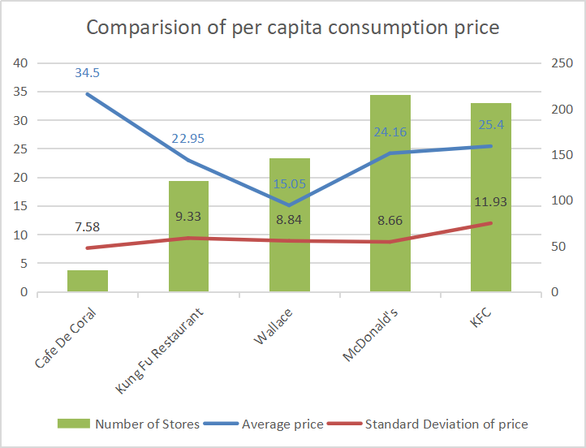
It is obvious that average prices are diversified, Cafe De Coral’s price is the highest (34.5 RMB), but consumers are still willing to afford more expensive food in Cafe De Coral, and are willing to join the online comments on website Dianping, although Cafe De Coral has the least number of restaurants in Shenzhen, compared to other restaurants. And the most signature product in Cafe De Coral is “baked thick pork chop with rice and cheese “(一哥焗猪扒), with the price 34 RMB, consumers’ willingness to pay can be related to the popular product “the baked thick and port chop with rice and cheese”(一哥焗猪扒). Since consumers became more value driven and price sensitives, the differentiated strategies that Cafe De Coral took include providing quality dishes and creating new dish choices, to make the quality of food more attractive and valuable.

As the smallest fast food supplier, compared with the rest 4, in terms of numbers of restaurants in Shenzhen, Café De Coral got huge volume of comments, much higher than the others. It is uncommon as target consumers of fast food are always in pursue of convenience and shorter meal time, who are not likely to spend additional time rating the canteens.
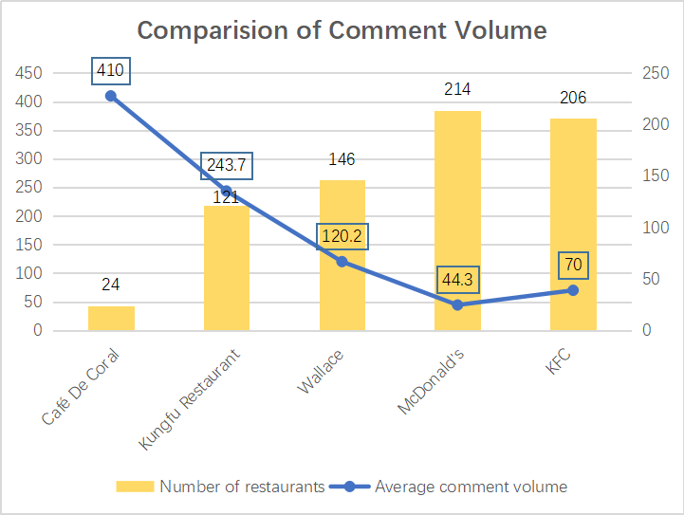

Given that some providers on Dianping would hijack the reviews and ratings via “online water army” to improve attract new customers, we further parser the account information of the customers. Normally, the fake accounts are at low user levels.

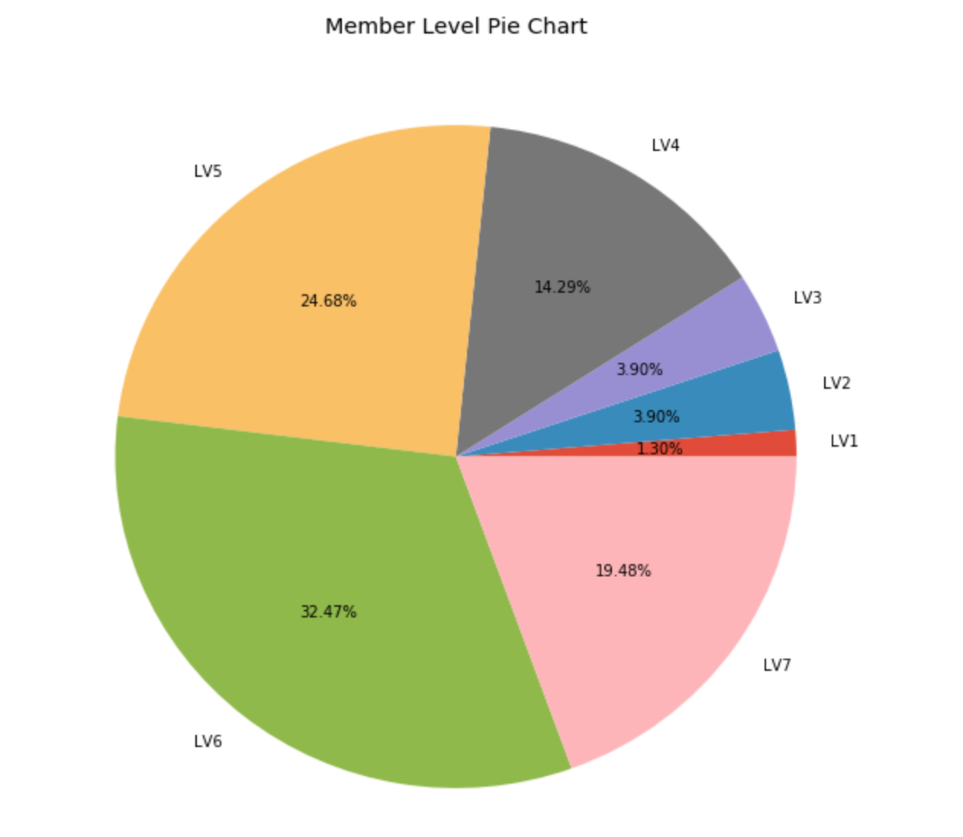
Data shows that over three quarters of the Café De Coral customers are above level three, meaning that they are they are not the new registered ones but the authentic customers of the restaurants.

Adding “Time” as a variable, we can find out there is an outburst of comments in 2018.
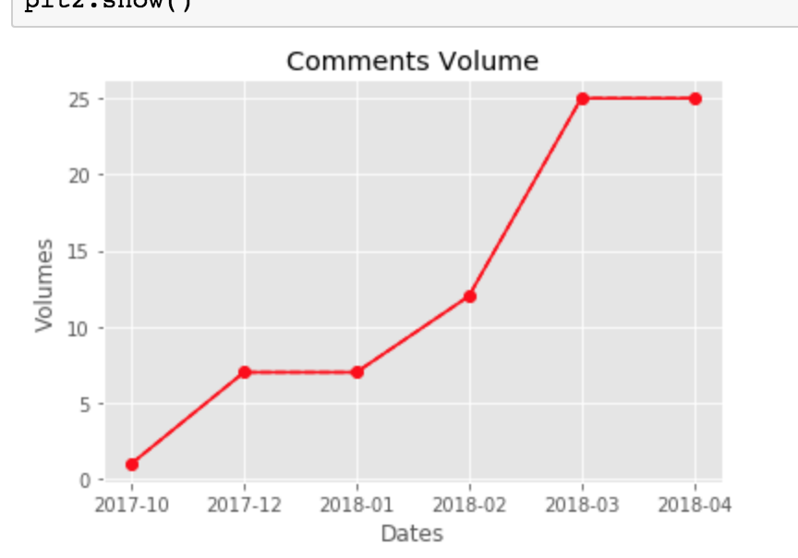
- Possible reasons behind
Then we refer 2017 financial statements of Café De Coral, reporting an 6% increase of revenue in fast food business in South mainland China. They attributed their success to deep knowledge of local tastes by revamp of menu, new customer relationship management program by brand building and new business model including e-commerce and O2O deliveries in response to changes in consumption behavior and higher service expectations among customers.

It seems their strategy works. O2O deliveries can well explain their higher volume of comments compared to KFC and McDonald’s, which only provide delivery on their own platforms but not on Dianping. Users will be more likely to comment on deliveries once finish their meals in office or at home than on-site meal.

Meanwhile, Café De Coral launched the “Happiness First” brand campaign and their new 6G concept store to build on their strengths as “the Canteen for Hong Kong People”. They also initiated a large-scale Customer Journey program under which they will continue to generate a high level of brand awareness.

Quickly updated menu will fresh the customers and motivate the consumers to comment on new products. Brand building may also be a reason. Loyal customers will develop a connection inside with the brands they favor, which will encourage them to rate the restaurants more frequently.

To verify the customers’ impression of Café De Coral, we analyze the comments and make a word cloud.
“Café De Coral” itself is the most frequent word mentioned by the consumers. It somehow proves the brand awareness of Café De Coral among the audience. “Pork Steak”, “milk tea” and“afternoon tea” shows their success strategy in menu setting with strong Hong Kong canteen characteristic.

- Hints from Café De Coral
By looking into Café De Coral’s case, we think differentiation may be the key reason they maintain customers with higher loyalty. Differentiation comes from many aspects. From the data we scraped, it mainly comes from localized and frequent updated menu rather than standardized courses, decoration and service.

What McDonald’s and KFC is missing may be those who willing to pay higher price but love the new and loathe the old while have strong desire to express their preferences. Other fast food brand building peers probably should learn about attracting customers to interact more.

- Highlights on our superior coding!

